Dorsal

Lateral

Superior

Caudal

Posterior

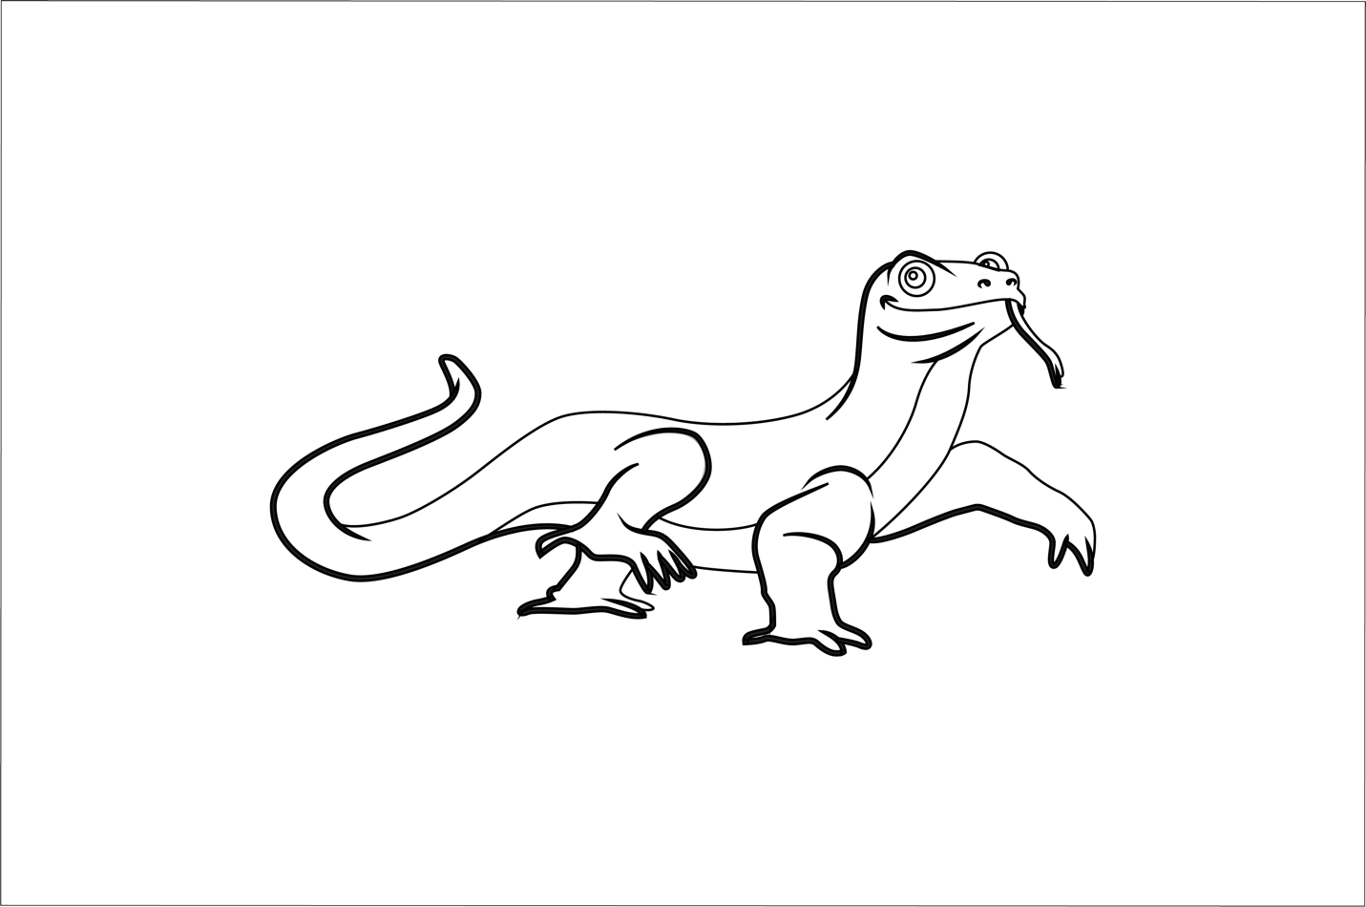

Proximal

Distal

Ventral

Cranial

Anterior

Inferior

Bonus question: What is the plural form of the word 'genus'?

Boa;lskjasdfkljfsalfadkldfalkjlefwjqhw]gp jp gr nfsq