Practice questions, Herpetology test 2, 2013

1 Draw a phylogenetic tree of Ascaphidae, Alligator missippiensis, Ranidae,
Sphenodon, Anolis, Crotalus atrox, Ambystoma, Plethodon, Triadobatrachus.

2 Give a node-based definition for the group-name Reptilia. Give a stem-based
definition for Sauropsida, which includes the extant Reptilia and its fossil sister species that evolved after the evolutionary split of Reptilia and Mammalia.

3 Describe a herpetological example where phylogenetic rooting position is important for explaining differences between results from different studies.

4 Give two synapomorphies for each of the following groups. Also describe each
synapomorphy in terms of its structure.

Anura
Squamata
Chamaeleons
Gymnophiona
Testudines
Amphibia

5 Describe functions of the turtle shell.

6 How could you distinguish a caecilian from an amphisbaenid? (what morphological character(s)?) How would you distinguish a snake (Serpentes) from an amphisbaenid?

7 Describe different types of skulls found in families of Gymnophiona.

8 Describe the history of studies of the relationships of the three major lineages of
amphibians (relative to each other, NOT within lineages). What relationships have been suggested for these lineages, what evidence has been offered, and what relationships are preferred today?

9 Draw a phylogenetic tree of the relationships of Ranidae, Ascaphidae,
Leiopelmatidae, Bombinatoridae, Pipidae, and Bufonidae. On this tree, identify the
branches where major changes occur in pectoral girdle structure, number of presacral vertebrae, and presence/absence of ribs. Be sure to note the exact nature of the evolutionary change (e.g., "from 9 to 8 vertebrae").

10 What is paedomorphosis? How might paedomorphic characters mislead
phylogenetic analyses of salamanders? List two species of salamders that evolved

paedomorphic traits convergently. Also list two species of salamanders for which
paedomorphic traits are homologous.

11 How can you distinguish Sirenids from Amphiumids?

12 Approximately how many species are recognized in the Family Plethodontidae?
(2, 25, or 350)

How many species are in the family Ascaphidae? (2, 25, or 350)

13 Contrast internal fertilization in frogs, salamanders, and caecilians.
Explain your answers.

14 Describe the skin of amphibians, including unusual traits relative to other
Tetrapods.

15 List some characteristics that vary between caecilian species.

16 Describe the history of phylogenetic studies of reptiles, including alternative
hypotheses, problem taxa, and current studies.

17 Contrast zygokrotaphic and stegokrotaphic skulls.

18 Contrast the skull of a caecilian with the skull of a frog.

19 Which of the following is NOT true of Billy Dee Williams?

a. He played Lando Calrissian in the Star Wars movies
b. He was in the movie "the Ladies' Man"
c. he is one smooth operator
d. he won an Academy Award for his role in "Shakespeare in Love"
e. he did commercials for Colt 45 malt liquor

20 Discuss the history of phylogenetic analyses of Anura. Include discussion of
major taxonomic groups, phylogenetic approaches, data, and authors. What hypothesis is currently favored?

21 List as many families of turtles as you can, and say whether each is a member of
Cryptodira or Pleurodira. List a distinguishing character of these two lineages.

22 Which of the following is true? Explain your answer.

a. Triadobatrachus is more closely related to frogs than to salamanders
b. Triadobatrachus is approximately equally related to salamanders and frogs but more distantly related to caecilians
c. Triadobatrachus is approximately equally related to salamanders, frogs, and caecilians

23 Discuss the diversity, anatomy, range, and natural history of one of the families of
frogs.

24 Characterize the following groups as arboreal, fossorial, aquatic, and/or terrestrial (list all terms that apply).

Gymnophiona
Caudata
Typhlonectes
Serpentes
Iguanidae
Amphisbaenia
Anura
Hylidae
Pipidae
Rhinophrynidae
Ambystomatidae
Chelonidae
Testudinidae

25 Do caecilians engage in parental care? If so, give an example.

26 Describe the hearing system(s) of amphibians.

27 Members of which amphibian group have a tentacle? What is a tentacle?

28 For each family of Salamanders discussed in lecture, describe geographic range,
approximate number of species, and general morphology.

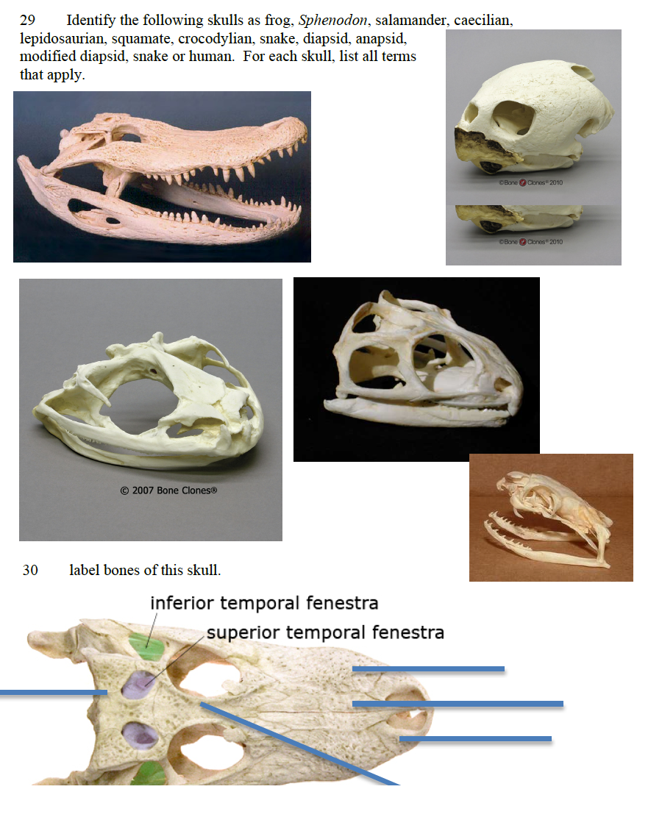

31 A new Family, Chikilidae, was erected for some species of Gymnophiona found
in India. Did the rules and standards of taxonomy require that a new Family be erected, based on the results presented by Kamei et al. (2012)? If not, what other options were available to the authors? Suggest a valid, existing, alternative Family name for the caecilians assigned to Chikilidae.

32 What is an eft? List a genus of salamanders that includes an eft stage in its life
cycle.

33 Wilkinson et al. and Pyron and Wiens propose alternative taxonomies of
Caecilians. Argue (present evidence, use logic) in favor of one of these systems, or argue that they are equally valid.

34 Discuss alternative arrangements of jaw-closing musculature in caecilians.

35 Describe why frog populations have declined or gone extinct in El Cope (Parque Omar Torrijos) park in Panama. What conservation measures have been taken to counteract these declines?
36 Describe alternative hypotheses of relationship for squamates due to molecular and morphological data. Discuss authors, methods, results, the position of Iguania, and which hypothesis you find more compelling and why.
37 How would you distinguish a Scolecophidian from an Alethinophidian? List an example species from each group.
38 list Families of lizards, and give some biological information on each Family.
39 How would you distinguish an amphisbaenid from a snake?
40 How do conflicting hypotheses of evolutionary history in squamates affect the interpretation of feeding ecologies in these lineages?
41 Describe the phylogenetic positon, skull structure, conservation status, number of species, and reproductive biology of Sphenodon.
42 True or false (if false, list a counterexample):
Heloderma are found in the USA
Lacerta are found in the USA.
Varanidae are phylogenetically sister group to the rest of Squamata.
Amphisbaenids and Serpentes have evolutionarily lost limbs. Other squamate lineages have not lost limbs.
Gekkota possess four well-developed limbs.
43 List species of Heloderma.
44 Discuss venom delivery systems in squamates.
45 Describe structure and function of the tongue in squamates.
46 Discuss skull structure as it relates to the ability of snakes to swallow very large prey.
47 Discuss crocodylian farming as an approach to conservation of crocodylians. Discuss a species for which farming has been a successful conservation approach.
48 Interior crocodile alligator. I drive a Chevrolet movie theater. Interior crocodile alligator. I drive a Chevrolet movie theater. Interior crocodile alligator. I drive a Chevrolet movie theater. Interior crocodile alligator. I drive a Chevrolet movie theater. Interior crocodile alligator. I drive a Chevrolet movie theater. Interior crocodile alligator. I drive a Chevrolet movie theater.
49 Describe some complex social behaviors in crocodylians (feeding, reproduction).

